1. –What Is an ERP ?
2. enterprise resource planning (ERP)
   1. Introduction
   2. Definition
   3. Characteristics of an ERP
   4. The components of an ERP
   5. Choosing an ERP
   6. The Benefits of ERPs
   7. The principal proprietary ERPs
   8. The main Open-Source ERPs
   9. Open ERP (Odoo8.0)
      1. Definition of Open Source
      2. Comparison between Open-Source ERPs
      3. History of Open ERP (Odoo)
      4. The benefits of Odoo
      5. Open ERP Modules (Odoo)
   10. Conclusion

ENTERPRISE RESOURCE PLANNING (ERP)

* 1. Introduction

In a classic management of a company, each department has its own information system and its own applications (accounting, payroll management, Inventory, commercial management, production management, etc.). To make the connection between these different systems, the company had computer interfaces developed between its different IS. This mode of operation was very expensive for the company, and it became inappropriate.

To improve this situation, companies have decided to implement systems known by integrated management software packages "PGI" or in English Company “ERP” planning resource.

Réf : C:\Users\nasTim\Desktop\ERP\Developpement-dune-solution-ERP.pdf

* 1. Definition

An Integrated Management Software or PGI (Enterprise Resource Planning or ERP) is a "software that allows you to manage all the operational processes of a company, integrating all the functions of the latter such as the management human resources, management accounting, financial, but also the sale, the Distribution, supply, E-commerce, etc. »

Ref : <file:///C:/Users/nasTim/Downloads/Documents/cours6_2.pdf>

* 1. Characteristics of an ERP

The four characters of an enterprise resource planning (ERP) system includes the following:

* **Modular Design**- The modular design of an ERP system incorporates distinct business modules such as manufacturing, financial, accounting, and distribution. Each module takes care of various functions of a particular section or department within your organization. While these modules can operate separately, they are integrated inside the ERP system to provide a seamless flow of data and information between all modules. This ultimately will enlarge the operational transparency provided for by the standard interface. These separate modules work in real-time with online and batch-processing capabilities.
* **Central Common Database**- Implementing a common centralized database management system, which is also called a DBMS, is an important characteristic of an advantageous ERP system. All data is entered and stored only once and then utilized by all departments simultaneously which helps eliminate data-entry errors and other flaws associated with using a distributed database.
* **Flexible and Open Database**- Organizations are almost always dynamic in nature, which is where ERP systems offer flexibility to respond to the changing needs of the enterprise. These systems have an open system architecture, allowing them to attach or detach any module as and when required without affecting the other modules. An advantageous ERP system should support connectivity to other business entities within the organization and shouldn’t be confined within the boundaries of a manufacturing facility.
* **Automatic Generation of Information**- An ERP system provides business intelligence tools such as executive information systems, decision support systems, easy warning systems, and more. These tools help manufacturing operations to make data-based decisions that pertain to their overall production process. All financial and business information will be automatically generated from the data that is found in the centralized database of the ERP system.

Ref: <https://www.planettogether.com/blog/characteristics-of-enterprise-resource-planning-erp>

* 1. The components of an ERP

Five Main Components of the ERP system are as follows:

1. Finance:

It keeps a track on all your financial data including Accounts receivable, Accounts payable, General ledger, costs, budgets, and forecasts. It helps to keep a record of cash flow, lower costs, increase profits and make sure that all the bills are paid on time. The growing complexity of the business makes important the need to have a single system to manage all of the financial transactions and accounting for multiple business units or product lines.

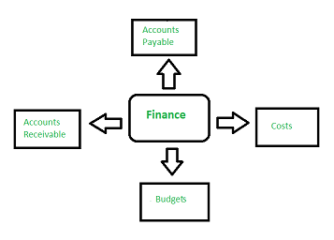

Finance Component

2. Human Resources (HR) :

It is a software handling all personal-related tasks for managers and employees. Employees play a very important role in any organization, without them business would not exist. This component is responsible for automated payments to employees, payment of taxes, generating performance reports, attendance tracking, promotions, deciding working hours and holiday hours of the staff.

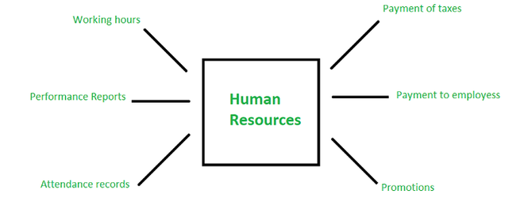

Human Resources (HR)

3. Manufacturing and logistics:

It as a group of applicants for planning, production, taking orders and delivering the products to the customers. It provides you a view of the demanded and achieved levels which is important to check whether you are achieving your targets or not. It provides all the stock summary and production plans beneficial for the business. It includes Production planning, order entry and processing also the warehouse management.

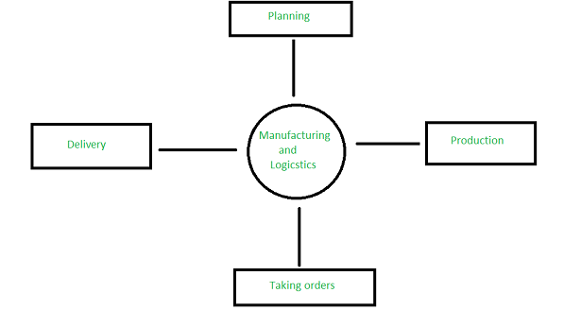

Manufacturing and logistics

4. Supply Chain Management (SCM) :

A supply chain management is a network of facilities that perform the procurement of the materials and transformation of these materials into intermediate and finalized products and distribution of these products to the customers. Planning, Manufacturing, Marketing, Distribution and the purchasing organizations through a supply chain operate independently. These organizations have their own goals and objectives.

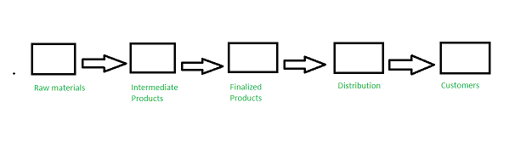

Supply Chain Management (SCM)

5. Customer Relationship Management (CRM):

This component interacts with the customers using data analysis to study large amount of information. They target the audience and observe what is beneficial for them. The component gathers customer data from multiple channels. Hence, CRM stores detailed information on overall purchase history, personal info, and even purchasing behavior patterns. The benefit it gains is by keeping a track on the customer’s buyer history and suggesting additional purchases.

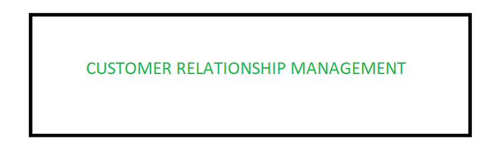

Customer Relationship management (CRM)

Ref: https://www.geeksforgeeks.org/erp-components/

* 1. Choosing an ERP

### **1. The Functional Fit for Your Organization**

This might seem straight forward but evaluating how the functionality of ERP software products and services fit with your business is the most important (and time consuming) aspect in the ERP selection process. Finding the best functional fit includes evaluating ERP software, watching ERP demos, and meeting with solution consultants. It also includes internal work. One of the most helpful things you can do during a selection project is facilitate internal discussions to determine your business requirements for ERP and outline the functional areas to address. Key questions that can help shape these discussions are:

* What is outdated about your current system? Why are you considering a new ERP?
* What works well with your current business systems?
* What manual processes could you potentially automate?
* In what areas of the business are you lacking visibility – or have a hard time with reliable business reporting?
* What other systems need to be integrated with the ERP?

The result should be a detailed list of requirements for new ERP software solution. The list should be prioritized and agreed upon by key leaders within the organization – with buy-in from IT as well as the overall executive team.

### **2. Industry Experience**

Another good question to ask during an ERP selection is: what ERP software is used in your industry? While not necessarily industry-specific, some ERP solutions are optimized to perform best in industries such as manufacturing and distribution. This is an important question that can help narrow the list of the ERP software you evaluate. Industry is a factor to consider not only with your software vendor (Oracle, Microsoft, Infor, NetSuite etc.) but also with your implementation partner. Whether or not the vendor and the implementation partner has had success in your industry is essential.

### **3. Price**

There are a few areas to consider when it comes to the price of your ERP software and implementation.

Return on Investment

The ROI of a new ERP can be measured in a few ways.

* Are there are specific areas of the business where cost savings can be achieved through new technology? For example, better [inventory management](https://terillium.com/erp-definitions/inventory-management/), faster financial close, automating manual or time-consuming tasks.
* Are there technology costs that can be reduced through the new ERP? Cost savings can result from a reduction in hardware or support, new software licensing agreements, or a reduced software footprint.
* What is the long-term ROI? There is no question that the initial software and implementation cost will be a financial investment for your organization. What does the ROI need to be after year one, year five, and beyond, to make the new technology worth it for your business?
* What capabilities will new ERP software enable? Faster ship times, better customer service, streamlined business processes, operational efficiency, modern e-commerce, warehouse and inventory management, real-time business reporting. These are a few of the potential new benefits that should be considered during an ERP selection process.

### **4. ERP Vendor Viability**

The viability of an ERP software vendor is crucial to consider as far as ERP selection criteria, including:

* Product viability: how long has the product been on the market, what is the future software roadmap, what is the research and development investment in the product
* Size of customer base: how many active customers use the software?
* Financial status: how solid is the software company?

### **5. ERP Implementation Project Considerations**

Finding the [right ERP consulting partner](https://terillium.com/erp-software-consulting/) for your business is step one for any successful implementation project and is a necessary aspect of ERP selection criteria. As you select your ERP software, and implementation partner, below are some aspects of the implementation project to consider:

* **Timing for the business.** Is it the right time to take on this project? If not, when? This is often a difficult question. In most cases, there’s never the perfect time – however there might be better times than others. For example, after a merger or acquisition might be the right time, or when deciding between a major (expensive) upgrade of your current system versus new software. Otherwise, the right time depends heavily on your team.
* **People and executive support.** An ERP implementation needs both executive support and involvement, as well as upper management and other key internal leaders on the project.
* **Methodology and a project plan.** To be successful, an ERP implementation methodology is fundamental. Thorough project planning and project communication tools are also keys to success.

### **6. The Technology**

In addition to software functionality, there are other technology considerations that are important to the ERP selection process. Best-in-class ERP software includes, at a minimum, these technology features:

* End user reporting tools – easier access to information, no development skills necessary
* Simplicity in UI and UX
* [Business intelligence](https://terillium.com/erp-definitions/business-intelligence/)
* Data security
* Reliable system performance and response time – very limited downtime
* Ability to integrate with other systems
* Ability to make necessary customizations

### **7. Risk**

Technology and ERP projects at the enterprise level inherently come with some risk. Selecting an ERP software with functionality that fits your business, along with many of the other criteria on this list (vendor viability, selecting the right partner, project planning, cost, executive support), goes a long way in mitigating risk during an ERP implementation.

Taking the time to create a thorough map of the key business processes that are essential for the operations of your organization, and using that throughout the ERP selection and implementation, will also negate risk. Essential elements to map out include integrations with other systems as well as necessary ERP customizations for your organization.

Change management and end-user training are also key areas to plan for in order to avoid risk.

Ref : <https://terillium.com/erp-system-selection-criteria/>

* 1. The Benefits of ERPs

There are many different ERP systems out there, but for the purposes of this post, we’re going to focus on the benefits of using ERP on the Salesforce platform. While many of the benefits are the same across the board, Salesforce enables additional capabilities and integrations to further connect business operations that would not otherwise be possible.

Here are the 10 primary advantages of a Salesforce-native ERP system that will help position your business for success.

### 1. Maximized planning and resource management

Enterprise Resource Planning is aptly named because it truly does enable planning across your organization so you know how to predict and forecast sales, costs, and the resources you need, whether that’s materials, equipment, or people.

ERP provides insights that enable you to effectively plan production schedules and forecast resource needs. When you can be predictive with events like equipment maintenance or order fulfillment, you can reduce unexpected downtime or production delays.

Better planning and resource management enable business leaders to make more effective decisions and overcome challenges across the entire business.

### 2. Greater enterprise collaboration

Personnel are often siloed across an organization, but ERP consolidates information from all departments into a single source of truth, making it simple to share accurate data in real-time.

Making all data available in one place, updated in real-time, has several operational benefits:

* Reduce errors often caused by using incorrect or outdated data
* Keep projects that otherwise could have been stalled due to a lack of information on track
* Graduate from merging disparate data sources and be confident in the accuracy, completeness, and security of your ERP-enabled data
* Eliminate human error that can come with manual data entry processes

### 3. Increased productivity

By automating major processes like inventory tracking or invoice generation, you can realize productivity gains across the board and place greater focus on tasks that may have otherwise fallen by the wayside.

And, we can’t restate enough the incredible time savings of having a single source of truth for data across departments. Manual data entry processes that took up valuable time in the past are now handled automatically – and with greater accuracy to save time on revisions.

ERP can perform advanced calculations quickly and automate tedious tasks. Your employees can place greater focus on a project, create more revenue-generating work, and use their time more efficiently and profitably.

Enabling teams to collaborate using accurate information enhances the success of your projects and ultimately brings about greater customer service.

### 4. Reduced overhead costs

When used properly, ERP systems can deliver significant cost savings to your organization.

* Prevent disruptions and delays that can be caused by a lack of accurate or available information, keeping projects on track and on time.
* Skip the additional personnel, software licenses, training on multiple systems, and administrative resources needed for traditional data unification software; ERP can be easily adopted and leveraged by existing staff.
* Streamline operations by making the tools for everything from product development to accounts payable available in one centralized system.
* Empower your team to use their time more efficiently by giving them the information and data they need, right at their fingertips.

Additionally, an ERP system provides greater visibility into changes in cost. Let’s say you typically pay $1 for a part, but suddenly the part costs $3. ERP will make it easy for you to see that cost differential so you can explore a different vendor or make adjustments to your budget to accommodate that additional cost.

### 5. Better customer relationships

Using ERP on Salesforce allows for integration with your Salesforce Customer Relationship Management (CRM) platform, drastically expanding the visibility you have over your operations. All customer information from purchase history to personal data is stored in one place and feeds directly into your ERP system to enhance the customer experience.

Using your ERP and CRM together, you can automate customer services like payment notifications for existing customers, or lead nurturing tactics for prospects currently in the sales pipeline. You can also enable sales and marketing teams with greater information to help close a sale.

Here are some other key benefits of an ERP and CRM solution:

* Streamline invoicing and accounts receivable
* Close the books faster at the end of each month
* Reduce billing or invoicing errors for a better customer experience
* Put customers in the driver’s seat with customized dashboards and portals
* Connect product, sales, and finance teams for alignment on product offerings and available revenue streams
* Generate impactful global financial reports using built-in analytics powered by Salesforce Tableau/Einstein
* Offer actionable, easily digestible information to your entire team through real-time dashboards

### 6. Improved quality control

Quality management is a significant benefit of an ERP system. Let’s say you have a product that has just completed the manufacturing process, but before you can sell the product, you still need to review and sign off on the corresponding paperwork. You can tell your ERP system that the product must be blocked from sale until the paperwork is approved.

This type of control over your internal flow of supply reduces the chance for error; i.e. someone clearing out a product that has not yet been officially released.

Additionally, ERP provides checks and balances over the system itself, so you can allow only the appropriate people to create or edit information, but make the information visible to those who need to see it. This kind of quality control over sensitive and timely data reduces human error and saves time when processes move more seamlessly among departments.

### 7. Better inventory tracking

Tracking and monitoring inventory is a challenge, especially for large companies that constantly have products coming in and going out and a high level of customer demand.

ERP systems are able to track individual inventory using serial numbers or RFID tags, and simple system inputs allow you to maintain visibility over all of your assets, even at different locations or when they’re in transit.

Supply chain management is simple, too – ERP simplifies logistics and distribution, and can be programmed to manage inventory goals and reduce inefficiencies.

What’s more, inventory tracking using an ERP system provides highly accurate inventory data for metrics like customer demand, the cost to ship or store, and over-or under-stocked items. In short: ERP allows you to better manage your inventory and control how costs are allocated.

### 8. Simplified risk management & regulatory compliance

Every business takes on some form of risk in the process of creating and disseminating products. ERP helps minimize those risks by reducing the likelihood of errors in accounting and financial processes and allowing for greater visibility and control over operational details. With forecasting tools, you can see whether you’ll need to increase labor to handle a busy season or ramp up production to handle growing demand.

Where revenue is concerned, every industry carries recognition rules and other compliance regulations that can result in fines or penalties if not properly managed. For this reason, companies need to be extremely accurate for IRS compliance, and an ERP system allows you to manage your finances accurately, legally, and easily with built-in auditing tools and easily generated reports.

### 9. Enhanced data security

Using ERP on Salesforce is the most secure way to store your data, hands down. ERP systems in general have built-in security controls to ensure data protection, but when used on the Salesforce platform, you get the benefit of the massive investments Salesforce has made into its security, ensuring the most up-to-date capabilities for event monitoring, authentication, encryption, and more.

### 10. Predictability & scalability

Without question, an ERP system allows your business to be more predictive, driving better business results that enable you to scale. You’re able to combine real-time data with greater flexibility and visibility, which gives you an enormous advantage when it comes to efficient product development.

Not to mention, changes in the market won’t have you stalled and grasping for a plan. You’ll already have accounted for fluctuations so you can keep your business running smoothly.

Ref : <https://www.financialforce.com/learn/erp/benefits-erp-system>

* 1. The principal proprietary ERPs

Today, many proprietary ERPs exist on the market. We will mention in what follows, some major publishers: ✓ SAP (Business One) SAP is the world leader in ERP, is a client-server application. Its modules cover all business management functions and each module covers complete management needs. This software package quickly gained significant success with large companies by offering a multilingual and multi-currency software package [5].

Oracle (JD Edwards) is an integrated management software package. Formerly called People Enterprise One or One World XE or ERP 8 and sold by J.D. Edwards then by Peoplesoft. J.D. Edwards was acquired by People Soft and then by Oracle. The product has since been renamed "Oracle JD Edwards Enterprise One". It is composed of several independent modules [5]. ✓ ERP SAGE Is an integrated management software package (ERP/PGI), designed for structures with 20 to 500 employees, independent companies and group subsidiaries, industrial, trading and service sectors [5].

Ref : C:\Users\nasTim\Desktop\ERP\Developpement-dune-solution-ERP.pdf

* 1. The main Open-Source ERP

The different open-source ERP software

Here is a non-exhaustive list of the main software on the open-source ERP market:

Aria,

Compiere,

ERP5,

Fisterra,

OFBiz,

OpenBravo,

ERP Suite,

Tiny ERP/Open ERP,

TiOlive,

Enterprise Value.

Modules and functionalities of an open source ERP

The modules and functionalities of an open source ERP are identical to those of a proprietary ERP. The main modules:

management of purchases, sales and supplies,

accounting,

management control,

production,

work organization,

storage, archiving, inventory,

logistics,

project management,

CRM,

human resources (holidays, pay, etc.).

* 1. Open ERP (Odoo8.0)

Ref: <https://steemit.com/odoo/@masterdubs/installer-odoo-8-ex-openerp-sur-centos-7-nginx-ssl>

Odoo is formerly called OpenERP and Tiny ERP. It is an open-source software package

integrated management system comprising a large number of modules to simplify the

overall business management. The software is used by more than two million

users to run their businesses around the world. Odoo is the ERP system

most popular open source

Odoo has three separate components: the server openerp-server which stores its data

in a PostgreSQL database, the openerp-client client which is installed on the

the user and the web server openerp-web which allows use from a

Navigator. These three components communicate via the XML-RPC and NETRPC protocols [6], [7].

The software is based on a strong MVC architecture, flexible workflows,

dynamic graphical user interface, an XML-RPC interface and a system

Customizable reporting with convenient OpenOffice integration.

Ref : <file:///C:/Users/nasTim/Desktop/ERP/Developpement-dune-solution-ERP.pdf>

* + 1. Definition of Open Source

Open source is a term that originally referred to open-source software (OSS). Open-source software is code that is designed to be publicly accessible—anyone can see, modify, and distribute the code as they see fit.

Open-source software is developed in a decentralized and collaborative way, relying on peer review and community production. Open-source software is often cheaper, more flexible, and has more longevity than its proprietary peers because it is developed by communities rather than a single author or company.

Open source has become a movement and a way of working that reaches beyond software production. The open-source movement uses the values and decentralized production model of open-source software to find new ways to solve problems in their communities and industries.

Ref: https://www.redhat.com/en/topics/open-source/what-is-open-source

* + 1. Comparison between Open-Source ERPs

In the functionality section only, some modules are listed. For details, please read the text. GNU Enterprise is not production ready now and does not have any ERP module.

L legend:

√ yes, x no

n/a not available ? unknown

+ above average ~ average - below average

(Average refers to the other evaluated open-source ERP systems)

Ref: C:/Users/nasTim/Downloads/Documents/ERPStudy.pdf

* + 1. History of Open ERP (Odoo)

Fabien Pinckaers, Founder and CEO of Open ERP/Odoo, created the software back in 2005. It was originally called **Tiny ERP**, changed to **Open ERP** around 2007 and then changed to **Odoo Open ERP** around 2012

Ref : <https://www.bistasolutions.com/resources/blogs/openerp-odoo-history-benefits>

* + 1. The benefits of Odoo

[Odoo](https://www.technaureus.com/what-is-odoo-or-open-erp/) is mostly favorable for small to mid-sized organizations. Many organizations develop Odoo app and place them in the market for sales or for free download. It’s opensource nature makes the source code is available for everyone. Let us have a look in to the benefits of Odoo ERP over other ERP systems.

#### **1. Extensible architecture**

Odoo allows and accept significant extension of its capabilities, without major rewriting of code or changes in its basic architecture.

#### **2. Available with no licensing costs.**

Cost of developing an ERP is so high, Odoo offers a Base ERP with no licensing cost. So that end user can maximize the budget for implementation and customization as per the requirement.

#### **3. Customization**

Users can customize the application to meet the business requirement. Which is a tailor-made concept, that provides unique features for each and every business in this competitive world. The strategy followed by each organization may differ from one another. Odoo offers highly customizable concept, which is really an advantage for businesses of all size.

#### **4. Open source**

Odoo community is an open source. The source code is available for everyone. In addition, Open-source model allows companies to access the ERP system’s code and customize it by themselves. It saves the business costs in the long run.

#### **5. Comprehensive in nature**

Odoo has two editions namely Community and Enterprise, community edition is open source, and everyone can assess, but enterprise edition will never be open sourced and the code will only available to Odoo and official Odoo partners. Odoo has about 30 core modules and 5000 community modules, which aid all the business management activities. These modules can be modified based on the requirements. The wide range of functionality and features will satisfy the business needs.

#### **6. Updated technology**

Odoo frequently updating and upgrading their technologies. This platform keeps on modifying along with the updated technologies.

#### **7. Easy to integrate**

Odoo integration is easy to configure, and it can be easily integrate with other ERPs only to improve their efficiency. Moreover, Integration with E-commerce will be an advantage for the businesses in this digital era.

#### **8. Highly secured**

Odoo ensure the accuracy, consistency, and security of data. So Odoo protect all business information that are confidential in nature.

#### **9. User Friendly**

Odoo is very easy to learn and understand. It provides good user experience.

#### **10. Flexibility**

Odoo offers plenty of modules. In which user can install modules as per their business needs. Also, they can add new modules when the business grows.

#### **11. Odoo studio**

Odoo studio helps the end user to create and build their own customized application. Also helps to add, remove, and modify screens of the system. Studio helps to design awesome reports.

#### **12. Responsive**

Odoo enterprise edition is responsive and community edition is not responsive till version 11.0. But version 12 onward all the three versions such as Odoo online, Odoo enterprise and Odoo community will be responsive.

Hence as an open-source ERP software, the Advantages Of Odoo ERP makes it as the best. So, while choosing an ERP software don’t think too much. Always choose the best platform and [services](https://www.technaureus.com/what-is-odoo-erp-odoo-erp-services/)..

Ref : https://www.technaureus.com/advantages-of-odoo-erp/

* + 1. Open ERP Modules (Odoo)

One of the characteristics that differentiates Odoo from many other ERP software is its modular architecture. There are over 35 base Odoo modules or Odoo apps, covering a vast array of business functions, from Manufacturing, Inventory, and Accounting, to Sales, eCommerce, HR, and more.

As a customer, this gives you a lot of power in your implementation. You can select the applications most relevant to your business and purchase and implement those. The modules all work functionally together, giving you access to one cohesive ERP system.

Not only does Odoo apps make Odoo easy to use, but it also makes it cost effective since you’re choosing only the modules that are needed for your company. Furthermore, you can set up access rules, so employees only have access to the sections relevant to them (e.g. marketing has access to marketing modules, salespeople to sales, accountants to accounting, etc.). This improves security for your system.

Ref: https://www.bistasolutions.com/resources/blogs/odoo-modules-list/

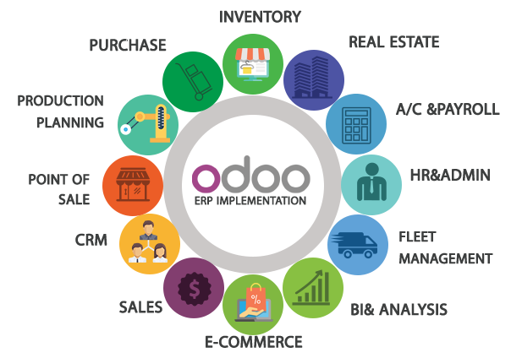

Réf : https://bsdinsight.com/phan-mem-odoo-va-cac-van-de-can-biet-ve-odoo/

* 1. Conclusion

We have seen in this part the basic concepts of ERPs which

helped us to have a general idea about the tool that we are going to introduce

in the last chapitre